Usability Report

Since there exist many websites developed for the same purpose, people will go to another site if they cannot figure out how to navigate the first one they visit. In fact, usability, the ease of being used, is very important for websites in order to make navigation clear and comprehensible for the user. In the early 90's Jakob Nielsen and Rolf Molich (Nielsen Norman Group, 1995) were the first who tried to evaluate usability with their heuristic evaluation, a method that identifies design problems. The heuristic evaluation is applicable to the Blackboard system.

## Visibility of system status

The system should always keep users informed by providing appropriate feedback within reasonable time. On blackboard that does not happen properly. While loading there is no information about progress, such as a loading bar. So, the user, if the page has problems loading, does not know why. The only thing they see is the browser loading spinning wheel.

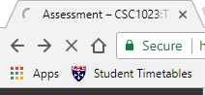

Fig.1: Spinning wheel

In the main page, the site gives you confirmation of changes made.



Fig.2: Update message

When the user is doing a test, the system shows the status of the question completion. If they skip a question, it warns giving an alert message.

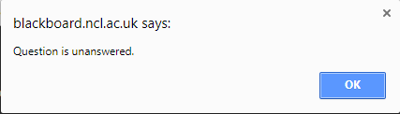

Fig.3: Warning message

  
Fig.4: Question completion status

## Match between system and the real world

The user should be able to understand every element of the website, but it is very common for the user to get confused. Therefore, the system must speak the language of the target user base.

To help the user understand the webpage, Blackboard presents a Global Navigation Menu. This menu provides an easy view of hyperlinks to the principal web pages:

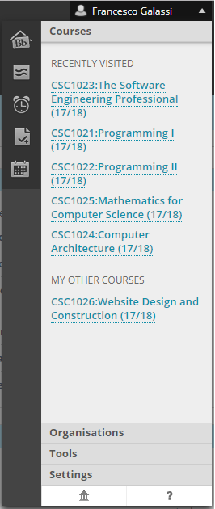

Fig.5: Global navigation menu

|  |  |
| --- | --- |
|  | A general overview of your current day |
|  | Posts page with discussion boards, blogs, journals, and wikis |
|  | Updates regarding tasks, lectures, assessment, Announcement and tutorials sorted in chronologically order |
|  | Grades sorted by subject and by date. |
|  | Calendar page for events |
|  | A horizontal menu with the recently visited course and additional features such as settings |
|  | It opens the homepage in another window as a pop-up leaving the old one still opened. It is hidden and the design looks like an ancient Greek temple rather than a house. |
|  | Help page with guides for students, instructor and administrators |

## User control and freedom

Users sometimes need to undo any accidental actions chosen by mistake and an “undo” button is the easiest way to help the user to leave the unwanted state without having to go through an extended dialogue. (Nielsen Norman Group, 1995)

To prevent mistakes if the user closes a panel in the “my institution” page, Blackboard asks a confirmation for the action.

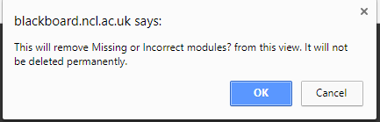

Fig.6: Ask for confirmation message

## Consistency and standards

According to the Nielsen, every element of the page that is displayed in a certain way should look the same across the site.

As a convention, people expect to find the login button to be at the top right corner (Craft Design, 2014). In the blackboard system, it is located next to the “help” button. The "Home" button is only a refresh button because it brings the user to the same page without any useful update.

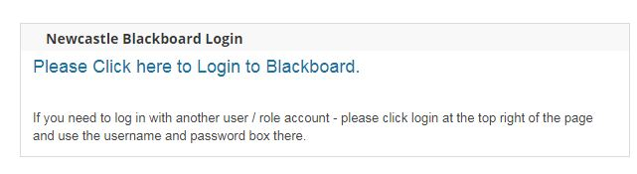

Fig.7: First login button

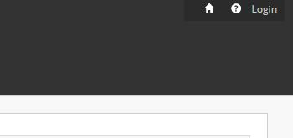

Fig.8: Second login button

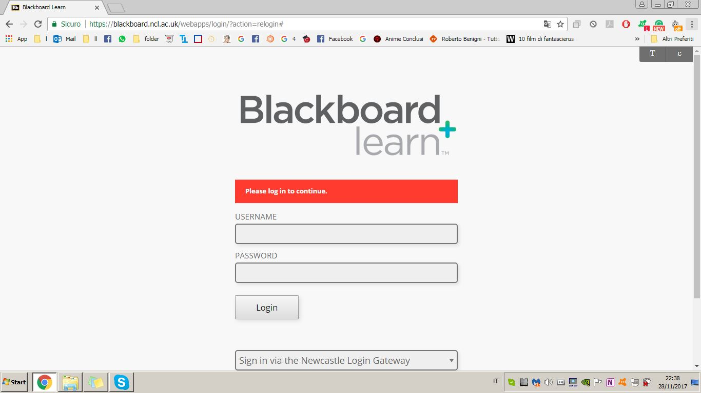

Fig.9: Login page

After entering the site the logout button, the power symbol (En.wikipedia.org, n.d.) is where expected. The top banner of Blackboard may cause confusion and user mistakes. Both the logout button and the Newcastle University button are here. Usually, the homepage button would be where the external “ncl.ac.uk” is found.

logo

Fig.10: Newcastle University logo

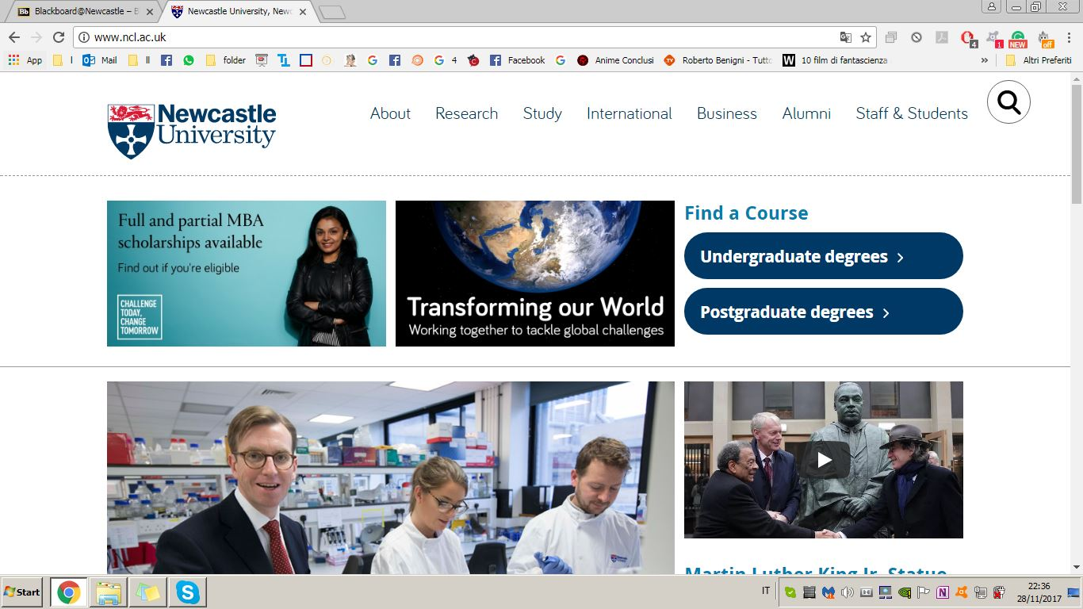

Fig.11: ncl.ac.uk page

Therefore, it would be preferable to have a big logo that could bring you in the main page not a small hidden one in a pop-up menu.

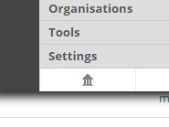

Fig.12: Home button

A positive element is the notifications red box, a little red sign with a number inside that shows how many new updates you still have to read.



Fig.13: Notification

## Error prevention

Users often commit mistakes so every website should be designed in order to prevent errors by helping the user to make the right choice.

In the system, help is provided when, for example, the user is doing a test. A warning message is given if the user clicks other links in order to change page or close it before finishing the test:

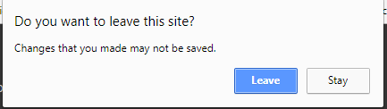

Fig.14: Warning message

However, the message would be improved if it said: “Do you want to leave this page” instead of “this site”.

Blackboard provides also a test to check if the browser is properly configured (Blackboard.ncl.ac.uk, n.d.). It tests if it supports JavaScript if it allows Cookies and if the user has a Java runtime environment installed.

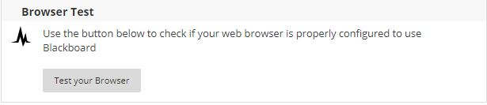

Fig.15: Browser test button

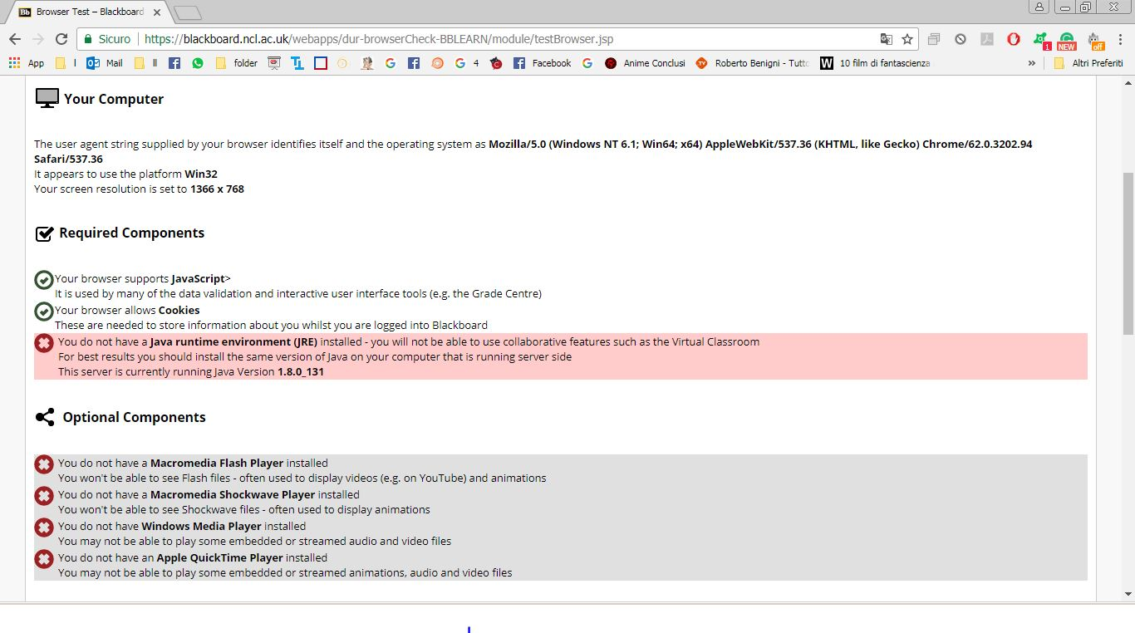

Fig.16: Browser test page

## Recognition rather than recall

Each of the website pages should be easily retrievable whenever appropriate.

If the user wants to visit the page related to recently visited courses, it is easily accessible by clicking on the Global navigation menu without remembering the specific areas.

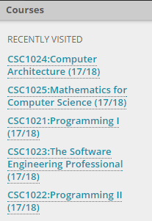 Fig.17: Recently visited courses list

When you are in a specific course section, the website shows you what course you are reading about instead of leaving the user to remember it.

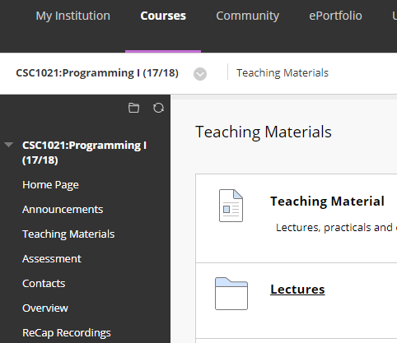

Fig.18: Course page

Another indicator is the violet active bar that highlights and bolds the menu section in order to show the right position. This allows the user to recognize what page they are working on.

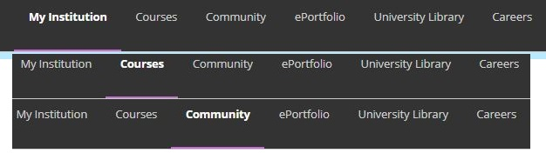

Fig.19: Navigation bar

In the login area, the system suggests the user how to use the page

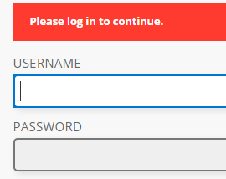

Fig.20: Login page message

## Flexibility and efficiency of use

The website is not only used by advanced users, so the interface should be easy to use for inexperienced users but also it should contain advanced features.

In the main page, you can find a personalisation bar menu with two button that allows users to add content or personalise the page.

In the settings menu, it is possible to change the text size.

Users can also select whether they will use your operating system's High Contrast settings and they can also personalise notification and personal settings such as avatar image or language (at the moment it is possible to select only English language).

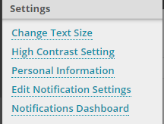

Fig.21: Settings menu

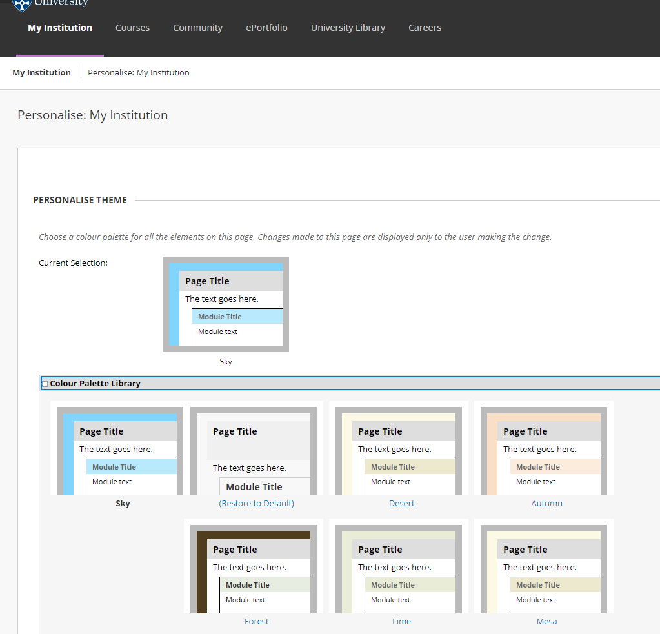

Fig.22: Personalization page

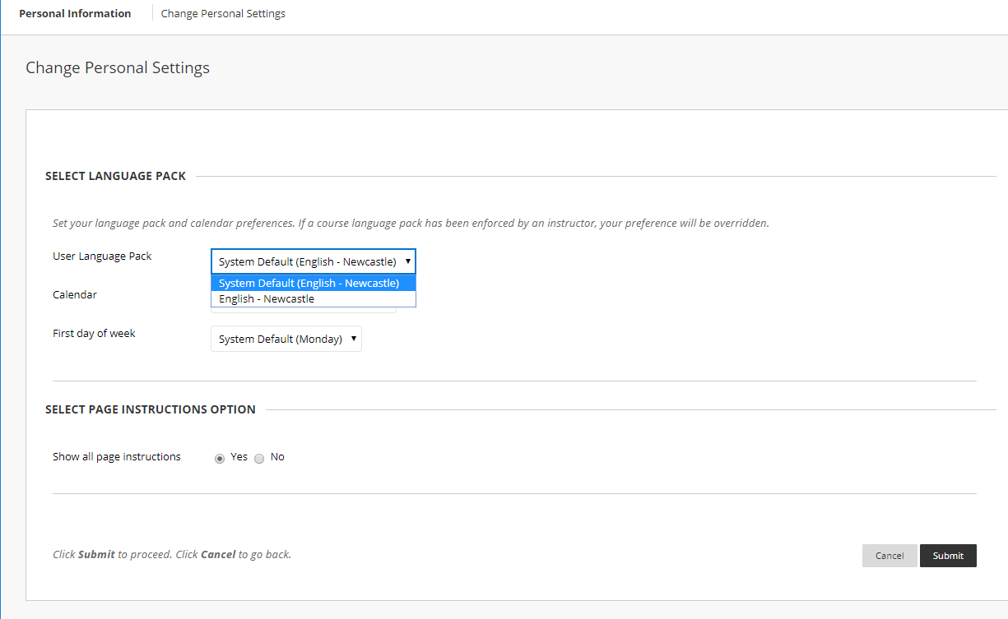

Fig.23: Personal settings page

## Aesthetic and minimalist design

The seventh guideline of heuristics suggests that the system presents information to users in a clear and minimalist way, giving only the information needed.

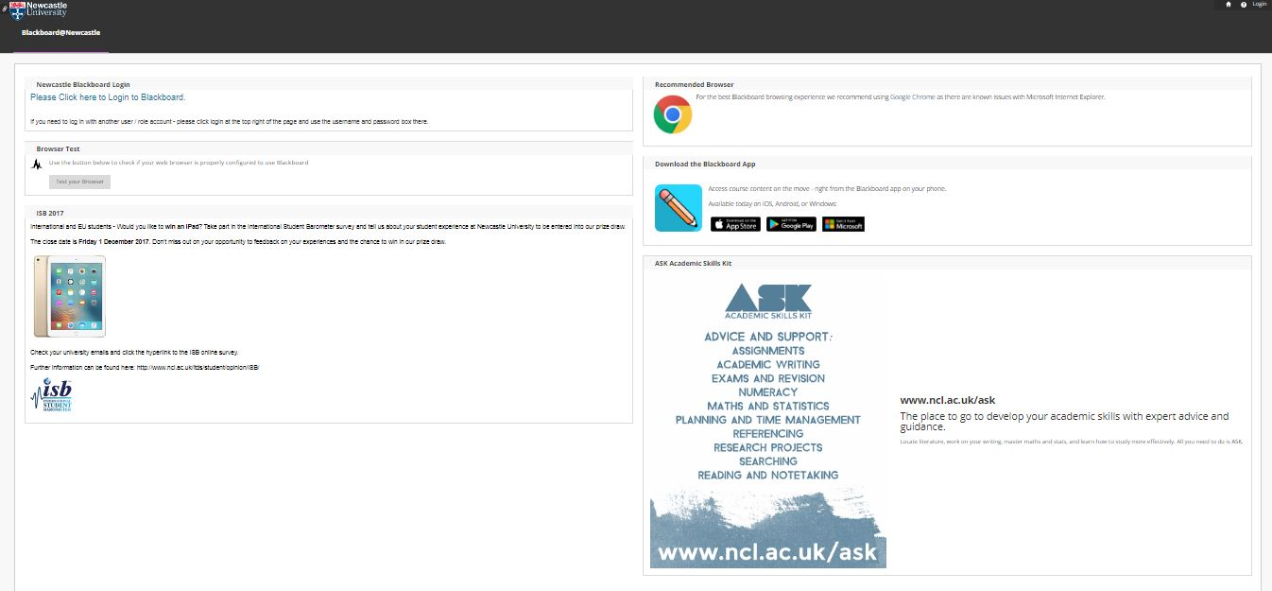

Fig.24: Main page (if not logged in)

In Blackboard the main and login page are organized into different text boxes, some of these show irrelevant or rarely needed information.

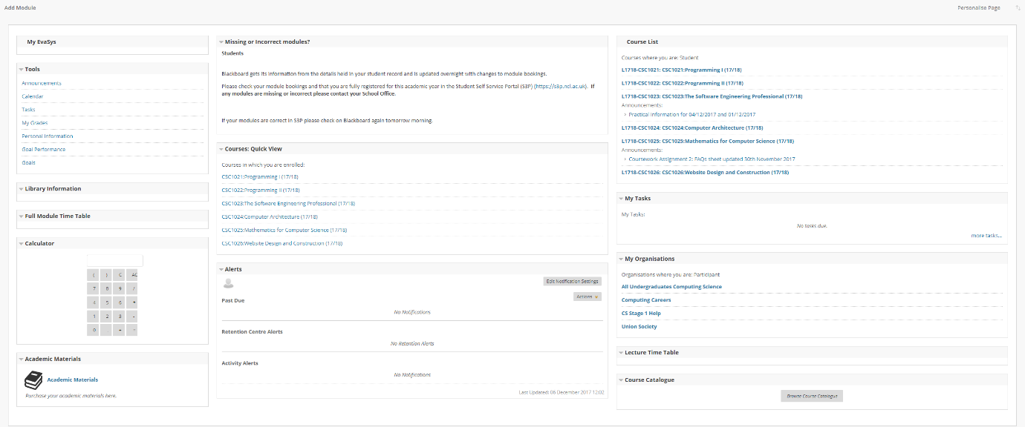

Fig.25: Main page (if logged in)

## Help users recognize, diagnose, and recover from errors

Often users make mistakes therefore errors should be explained in understandable language.

If the user enters wrong username or password the message is that either the username or the password is incorrect. The user is not informed if the username or the password is wrong.

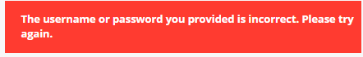

Fig.26: Login error

In the navigation bar, the user can click on the “Careers” button but instead of going to a page within this site as expected, it displays this error not easily explained:



Fig.27: Careers page error

## Help and documentation

Even though the system should be used without documentation, the user may need help if something is not right with the interface. Blackboard makes available a YouTube channel (Youtube.com, n.d.) and provides guides for students, instructors and administrators, just clicking on the “question mark” button.

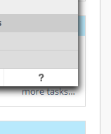

Fig.28: Help button

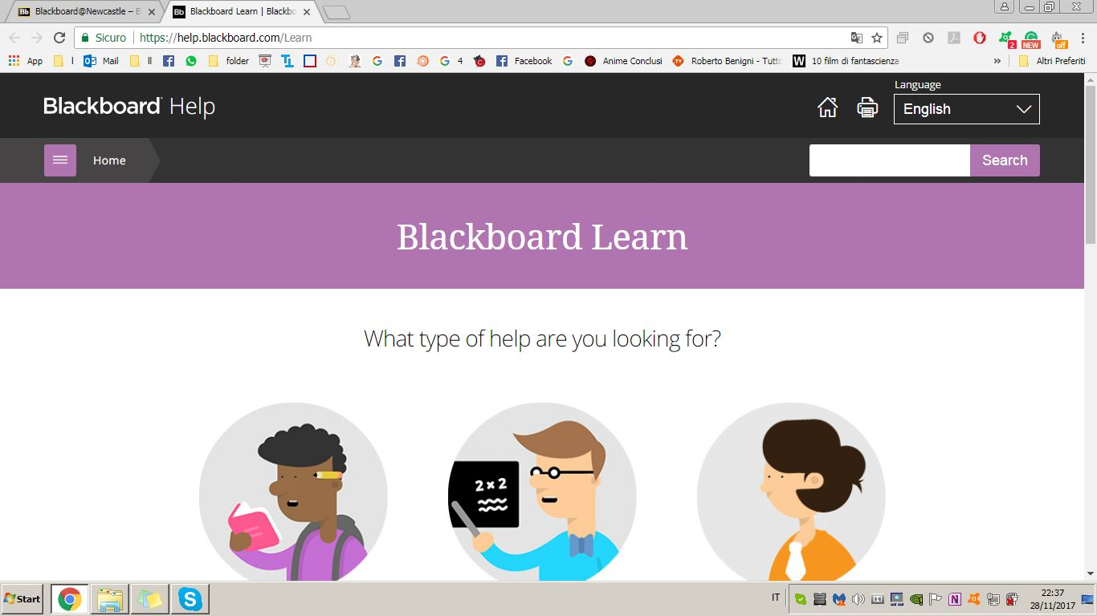

Fig.29: Help page

## Conclusion

The Blackboard system respect most of the Nielsen's principles but not all (Prototypr, 2016), in fact, some should be improved.

## References

En.wikipedia.org. (n.d.). Power symbol. [online] Available at: https://en.wikipedia.org/wiki/Power_symbol [Accessed 4 Dec. 2017].

Nielsen Norman Group. (1995). 10 Heuristics for User Interface Design. [online] Available at: https://www.nngroup.com/articles/ten-usability-heuristics/ [Accessed 5 Dec. 2017].

Prototypr. (2016). 10 Usability Heuristics with Examples – Prototypr. [online] Available at: https://blog.prototypr.io/10-usability-heuristics-with-examples-4a81ada920c [Accessed 5 Dec. 2017].

Craft Design (2014). 10 Usability Heuristics explained. [online] Slideshare.net. Available at: https://www.slideshare.net/crafted/10-usability-heuristics-explained [Accessed 5 Dec. 2017].

Youtube.com. (n.d.). blackboard app - YouTube. [online] Available at: https://www.youtube.com/results?search_query=blackboard+app [Accessed 5 Dec. 2017].

Blackboard.ncl.ac.uk. (n.d.). Browser Test. [online] Available at: https://blackboard.ncl.ac.uk/webapps/dur-browserCheck-BBLEARN/module/testBrowser.jsp [Accessed 5 Dec. 2017].